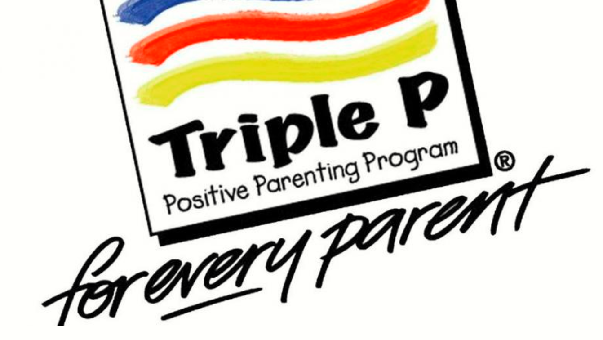
Triple P – Positive Parenting Program (Initial registration details)
Groups dates and times:
Monday 3rd June 09:30-11:30
Wednesday 5th June 18:00-20:00
Thursday 6th June 12:30-14:30
Monday 10th June 10:00-12:00
(Please state which group you would like to attend)

Five-week course.
Each session is 2 hours long via TEAMS

Family Details
Name
How many child/ren do you have?
How old are your child/ren?
Address (including postcode)
Email address
Telephone number
Reason you are requesting to attend Triple P Family Transitions?
What would you like to achieve from participating in the course
Any other details that would help the Course instructors?
Please fill out and return to Roxanne McDowell, Every Relationship Matters in Norfolk Coordinator with any further questions you may have:
Roxanne.mcdowell@norfolk.gov.uk or Melanie Perry, Team Manager melanie.perry@norfolk.gov.uk and specify which group you would like to attend.

