**Anna Hibiscus’ Song**

**Week beginning 30th September 2024**

**This week in phonics…**

We will be learning the ‘sounds’ made by the letters g, o, c & k.

We are learning to read the ‘tricky’ words ‘go’ and ‘of’.

**This week in maths…**

We will be comparing size, mass and capacity.

**Why this ‘theme’?**

We have chosen this theme to support the children in beginning to recognise and celebrate cultural

diversity for the start of ‘Black History Month’.

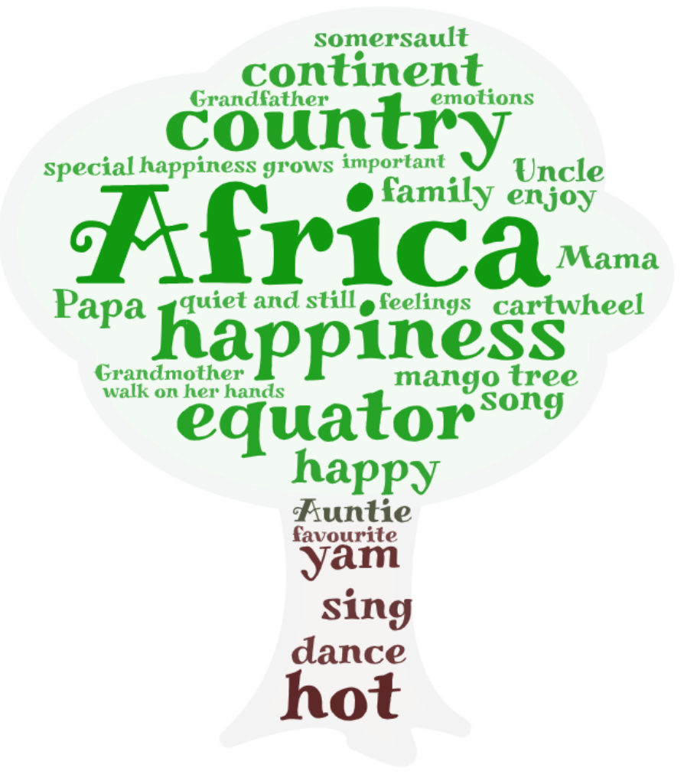

**Skills Focus**

**The World:** Looking on a map and making comparisons with countries in Africa and the UK.

**Expressive Arts & Design:** Exploring paintings and music from Africa.

**Personal, social and emotional**: Exploring and managing feelings.

**Key Vocab**

**The World:** Country, different, similar, map, weather, world.

**Expressive Arts & Design:** Describe, feel, lines, shapes, tools

**Personal, social and emotional**: Feelings, comfortable, uncomfortable.

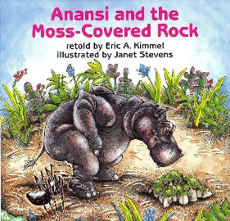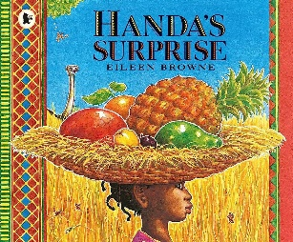

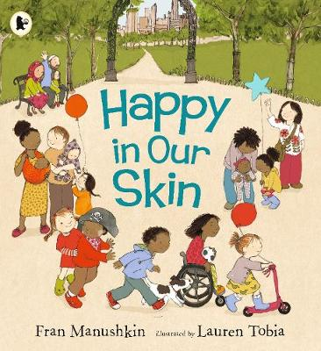

**Did you know…**

Africa is the second largest continent in the world.

There are 54 countries in Africa.

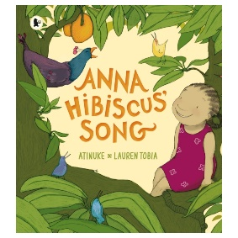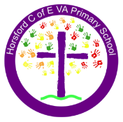 

**Phonics Focused Reading Book**

Look out for the phonic focused reading books coming home this week- we can now send home books that contain all the new sounds and tricky words we have been learning in class. Can your child recognise these when you read at home together? Don’t forget to make a note in the reading diary so we can move your child up on our class reading race! 😊

**I wonder…**

Would you rather it was always sunny, always raining or always snowing?

**We are a Church of England School…**

We say a prayer before lunch each day.

In our daily collective worship, we will be exploring this half-term’s theme of ‘Creativity’.

This week’s song: *‘He’s got the whole world in his hands’.*

School Values: Compassion • Respect • Responsibility

**Things your child can do at home:** Share fiction and non-fiction books based around other countries, noticing some similarities and differences, talk about things that make you feel happy, find different countries on a map or a globe, spend time with your family doing something that makes you feel happy, do something to make someone else happy.

**Homework:** Draw a picture of something that makes you happy, add your name using your name card and bring it in to go up on our ‘Home Learning’ wall.